System settings

System protection settings  Parameters in this section define channel output states on power up and in case when any of protection tripped to prevent or reduce possibility of damaging the connected loads.  Additionally, the system password that is used to unlock display can be defined or changed here. | 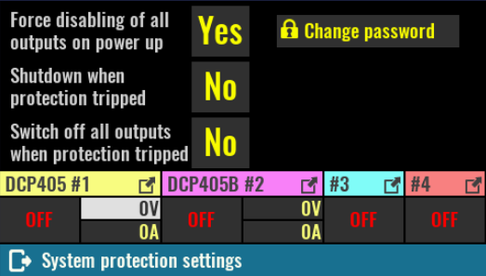
Force disabling of all outputs on power up
Active by default this option secure that all channel outputs will be switched off on power up to prevent connected loads from being damaged unintentionally.

SCPI
SYSTem:PON:OUTPut:DISable ON

Shutdown when protection tripped
When selected, any protection that tripped on any channel will automatically put the EEZ BB3 in standby mode.

SCPI
SYSTem:POWer:PROTection:TRIP ON

Switch off all outputs when protection tripped
Similar to previous option, but instead of entering standby mode all channel outputs will be turned off.

SCPI
OUTPut:PROTection:COUPle ON

Change password  The system password is used to unlock display. By default system password is not defined (“”) and it may contain up to 16 characters. Minimum length is 4 characters. The new password is automatically stored in non-volatile memory.  When selected an on-screen keyboard will appear. Characters entered will be replaced with * shortly after entry. The new password has to be entered twice. | 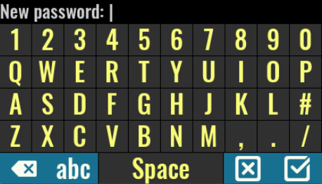
SCPI
SYSTem:PASSword:NEW {<old>}, {<new>}

Display settings  Display color theme selection, brightness, luminosity, animation duration, status of display can be selected on this page.  Option for entering screen calibration that is required on the first start is also available. | 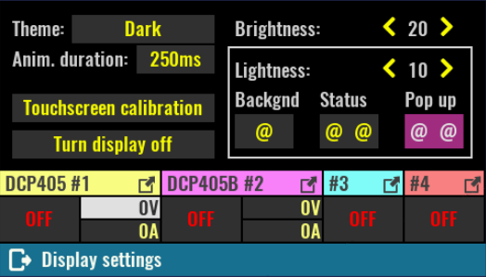
Theme
The EEZ BB3 comes with few color themes that are applicable on all pages. Default theme is Dark.

Anim. duration
Define how long will take animation effect when current page is replaced with the new one. Default is 250 ms. Set this parameter to 0 ms if you find that effect unnecessary.

Brightness
Controls the intensity of the display backlight. The range of the parameter is 1 to 20, where 20 is full intensity and 1 is fully blanked. Default value is 15.

SCPI
DISPlay:BRIGhtness {<value>}
Lightness
This parameter defines lightness of displayed colors if they are represented in so called HSL color space (hue, saturation, lightness). By increasing this value all colors will appear “lighter” or washed away. Similarly, when decreased all colors will appear “darker”, more dull. Lightness is not affected when set to 10. However, due to limitation of used display (color representation is reduced to 16-bit) a default value is set to 5 to effectively compensate color difference.
Result of changing this parameter can be directly observed on colors of three screen “widgets” (Backgnd, Status, Pop up).

Turn display off
By turning display off user interaction is no longer possible. To reactivate it, you have to touch it anywhere and hold for a short time.

SCPI
DISPlay OFF
Touchscreen calibration  Screen calibration is required to give the firmware the necessary information about its geometry, which will increase the accuracy of data entry.  Initiate this procedure as necessary if you notice that the accuracy of data entry is no longer satisfactory.  SCPI  CALibration:SCReen:INIT | 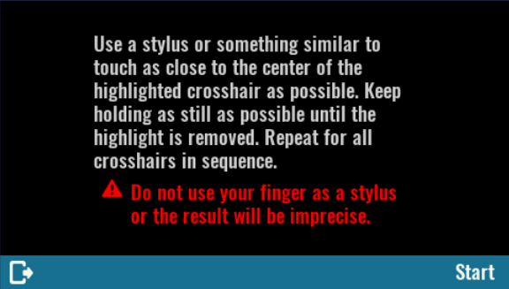
For a successful calibration, you have to use stylus or similar rounded tip object and touch the three dots on the screen as accurately as possible. | 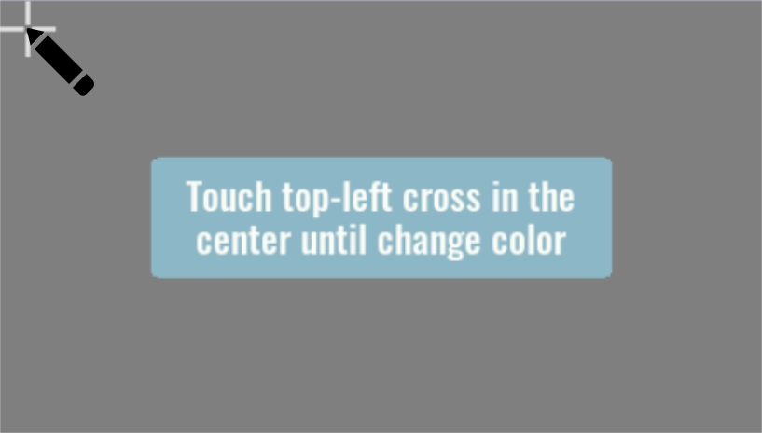
After successfully defining the three points, a new page will appear where you can choose between saving calibration data, repeating or canceling the calibration.  On the same screen is possible to test precision by touching the surface beyond the options mentioned. | 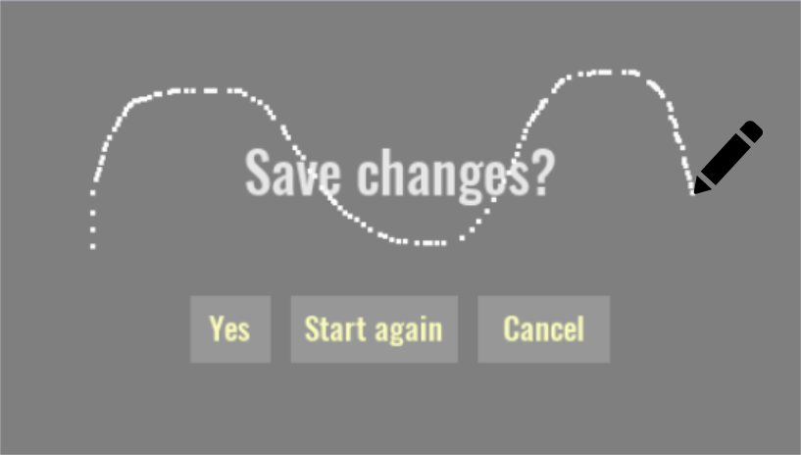

Sound settings  Sound  When the beeper is enabled, the EEZ BB3 generates audible sound in any of the following situations:  - the power is turns on or off,  - when error occurs during local (via display) or remote operation  - self-test is failed and  - any of the protection function is tripped.  SCPI  SYSTem:BEEPer:STATe {<bool>} | 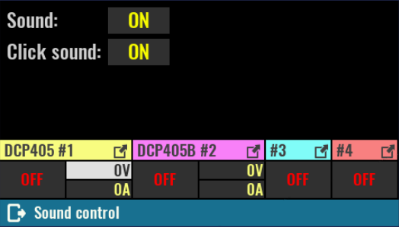
Click sound
Select this option to enable or disable generation of audiable “click” sound as confirmation of selected item on the screen.

SCPI
SYSTem:BEEPer:KEY:STATe {<bool>}

General trigger settings  The BB3's triggering system allows a change in output state, voltage and current or start internal data logging when receiving a trigger from selected trigger source.  One common triggering system is used to control all available channels, but will only affect those channels that are not in Fixed trigger mode (see Channel trigger settings for channel trigger mode settings). | 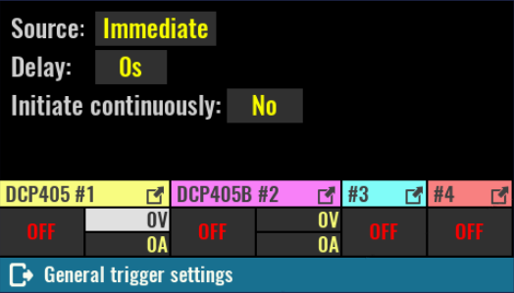
Source
- Bus – enables LAN and serial (via USB) triggering using the *TRG command. When this mode is selected, TRG text will blink when you turn on channels that have triggers defined (e.g. List or Step).
- Immediate – the EEZ BB3 executes a complete trigger operation immediately after executing the INITiate command without delay.
- Manual – allows you to manually trigger with the User SW (if assigned this function, see User SW) or by selecting the flashing TRG text that will appear on the screen as it shows the example in the picture to the right (Ch2 to Ch4 have triggers defined).  - Pin<n> – selects a digital port pin configured as a trigger input. <n> specifies the pin number. | 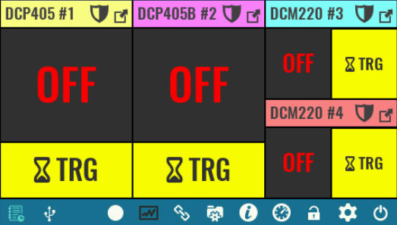
SCPI
TRIGger[:SEQuence]:SOURce {<source>}
Delay
Sets the time delay between the detection of an event on the specified trigger source and the start of any corresponding trigger action on the channel output.

SCPI
TRIGger[:SEQuence]:DELay {<delay>}
Initiate continuously
This option defines whether the trigger system is continuously initiated or not. When set to OFF, the trigger system remain in the IDLE state until it is set to ON or INITiate:IMMediate command is received.
Once it is set to ON, the trigger system will be initiated and exit the IDLE state. On completion of each trigger cycle, the trigger system immediately commence another trigger cycle without entering the IDLE state.
When this option is set to OFF, the current trigger cycle will be completed before entering the IDLE state. The return to IDLE also occur as the result of an ABORt or *RST command.

SCPI
INITiate:CONTinuous {<bool>}

Digital I/O settings  Two protected/buffered digital input and two digital output is available on the EEZ BB3 front panel. Their function and polarity can be set on this page and also observe their current state.  Function  Input pins could be assigned with one of the following functions:  - Input – The pin is in digital input mode. | 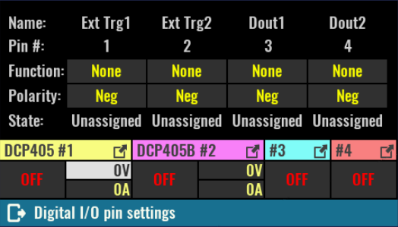
- Inhibit – When pin is configured as an inhibit input, a true signal at the pin will disable all output channels.  If the channel outputs were turned on, all output values will flash in red when entering inhibit mode, as shown in the figure to the right.  - Trigger input – When configured as a trigger input, the pin can be selected as the source for trigger signals. | 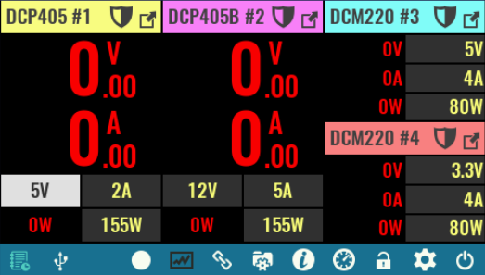
Output pins could be assigned with one of the following functions:
- Output – The pin is in digital output mode.
- Fault – pin functions as an isolated fault output. The fault signal is true when any output is in a protected state (from OCP, OVP, OTP, OPP) or Fan fault is detected.
- Channel ON couple – pin synchronizes channel output state.
- Trigger output – This allows a BUS trigger to be sent to any digital port pin that has been configured as a trigger output. A trigger out pulse is generated when the state is on and a bus trigger is received. A BUS trigger is generated using the *TRG command.

SCPI
SYSTem:DIGital:PIN<n>:FUNCtion {<function>}
Polarity
- Pos – a logical true signal is a voltage high at the pin. For trigger inputs and outputs, positive means a rising edge.
- Neg – a logical true signal is a voltage low at the pin. For trigger inputs and outputs, negative means a falling edge.

SCPI
SYSTem:DIGital:PIN<n>:POLarity {<polarity>}
State
Current state of all digital inputs and outputs are displayed in this section. If pin function is not yet defined, the displayed state will be Unassigned.

SCPI
SYSTem:DIGital:INPut:DATA? {<pin>}
SYSTem:DIGital:OUTPut:DATA? {<pin>}

Date & time  Date  Sets the date of the system clock (RTC). Specify the year, month, and day.  SCPI  SYSTem:DATE {<year>}, {<month>}, {<day>}  Time  Sets the time of the system clock (RTC). Specify the hours, minutes, and seconds. | 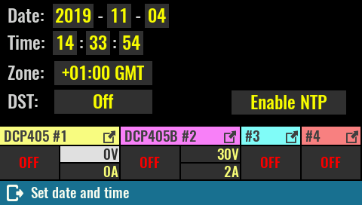
SCPI
SYSTem:TIME {<hours>}, {<minutes>}, {<seconds>}

Zone
Defines time zone as offset from GMT.

SCPI
SYSTem:TIME:ZONE {<zone>}

DST
Determines Daylight saving time (DST) rules used in your region. The following rules may apply: Europe, USA or Australia.

SCPI
SYSTem:TIME:DST {<rules>}

Enable / Disable NTP  Internal clock synchronization with NTP server can be enabled or disabled. When enabled, a NTP server entry field will be displayed.  The NTP communication requires active Ethernet connection.  List of most appropriate and available NTP servers: ntppool.org  SCPI  SYSTem:COMMunicate:ENABle {<bool>}, NTP | 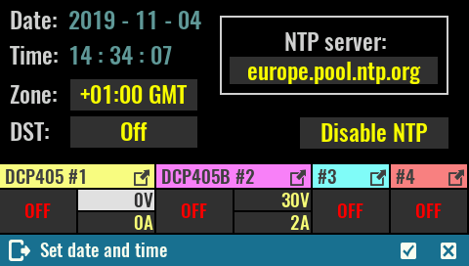
NTP server
NTP service server network address. The EEZ BB3 will try to establish connection with selected NTP service on each power up (hard reset), when *RST is issued or once per day.

SCPI
SYSTem:COMMunicate:NTP {<server>}

Encoder & User sw  Confirmation mode  The encoder comes with a tactile switch and if this mode is selected then it will be used to confirm the newly changed value. By definition, the mode is not selected and means that pressing the switch will move the "cursor" to the next editable field. | 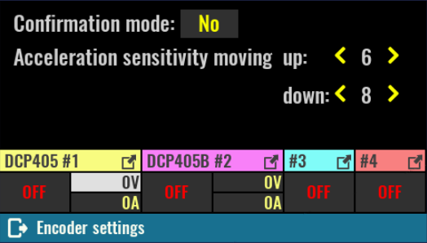
Acceleration sensitivity moving up/down
The rotation speed of the encoder is measured and defines in what steps the selected value will change.
The reaction (sensitivity) to increasing the rotation speed in one direction or the other (increasing values or decreasing values) can be set by these parameters.

System temp and fan  Current temp.  The "system" temperature is measured on the AUX-PS module and can be used for over-temperature protection (OTP).  SCPI  MEASure:TEMPerature? AUX | 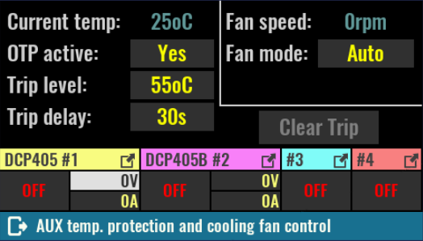
OTP active
Enable or disable over-temperature protection associated with the system (AUX) temperature sensor.

SCPI
SYSTem:TEMPerature:PROTection:STATe

Trip level
Set the over-temperature protection (OTP) value in degrees Celsius (ºC). Default value for this sensor is 45 ºC.

SCPI
SYSTem:TEMPerature:PROTection {<temperature>}

Trip delay
Specifies how long the temperature should be equal to or higher than the set trip level for the protection to activate.

SCPI
SYSTem:TEMPerature:PROTection {<temperature>}

Clear trip
When protection is activated (tripped), this condition will be latched and further usage of the EEZ BB3 will be inhibited until protection is cleared.

SCPI
SYSTem:TEMPerature:PROTection[:HIGH]:CLEar

Fan speed
Current fan speed indicator stated in rpm (revolutions per seconds). The diagnosed fan fault will be also displayed here.

SCPI
DIAGnostic:FAN?

Fan mode
Fan is controlled by default with firmware algorithm (Auto mode) that takes into account measured temperature on all temperature sensors and measured output currents (i.e. the higher the output current, the sooner the fan speed will increase).
Manual mode can be selected for e.g. fan testing purpose when firmware speed control algorithm is completely bypassed.

Set speed to
This option becomes available when manual mode is selected. Default value is 100 % (full speed).

Ethernet  Enable/disable  Defines activity of the serial interface. When LAN cable is disconnected or network communication is not yet established, Connecting … will be displayed until communication is not established again.  SCPI  SYSTem:COMMunicate:ENABle {<bool>}, ETHernet | 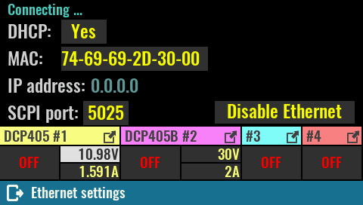
DHCP
Enable or disable the DHCP mode. In DHCP mode, the DHCP server in the current network assigns network parameters (IP address, DNS address, gateway address and the Subnet mask). Assigned IP address will we displayed, and cannot be changed.
When DHCP is disabled all network parameters have to entered manually using the Edit static address as described below.

SCPI
SYSTem:COMMunicate:ETHernet:DHCP {<bool>}
MAC  Defines Ethernet MAC address, a unique identifier assigned to Ethernet interface for communications at the data link layer of a network segment.  Any combination of six hexadecimal values is allowed separated by “-”. The Ethernet connection will work as long as two different machine in the LAN don't have the same MAC address. | 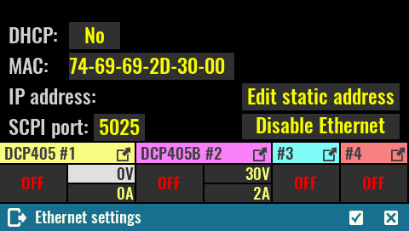
SCPI
SYSTem:COMMunicate:ETHernet:MAC {<mac_address>}

SCPI port
Defines Ethernet communication port for SCPI connections. Default port is 5025.

SCPI
SYSTem:COMMunicate:ETHernet:PORT {<number>}
The parameters that follows should be defined when DHCP is not selected. All values should be specified in IPv4 address format (four values from 0 to 255 separated by dots)  IP address  SCPI  SYSTem:COMMunicate:ETHernet:ADDRess {<ip_address>}  DNS  SCPI  SYSTem:COMMunicate:ETHernet:DNS {<ip_address>} | 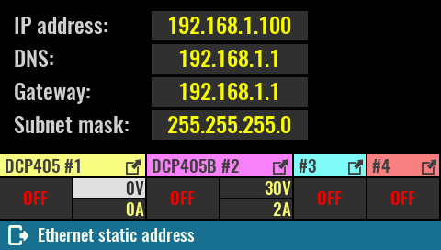
Gateway

SCPI
SYSTem:COMMunicate:ETHernet:GATEway {<ip_address>}

Subnet mask

SCPI
SYSTem:COMMunicate:ETHernet:SMASk {<mask>}

Serial (via USB)  Enable/disable  Defines activity of the serial (via USB) interface.  SCPI  SYSTem:COMMunicate:ENABle {<bool>}, SERial | 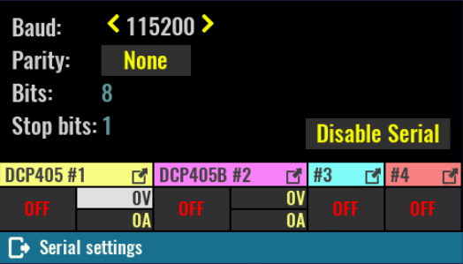
Baud
Select serial communication speed from list of predefined values (4800, 9600,19200, 38400, 57600 or 115200). Default speed is 115200 baud.

SCPI
SYSTem:COMMunicate:SERial:BAUD {<speed>}

Parity
Set the parity mode of the serial interface that could be Even, Odd or None. Default is None.

SCPI
SYSTem:COMMunicate:SERial:PARity {<parity>}

Bits and Stop bits are predefined and cannot be changed.

Channels calibration  Calibration password  The calibration password is used to secure access to calibration data.  Unlike a system password this password is defined by default (eezbb3) and have to be entered first before new password can be entered.  The calibration password may contain up to 16 characters. Minimum length is 4 characters.  The new password is automatically stored in non-volatile memory. | 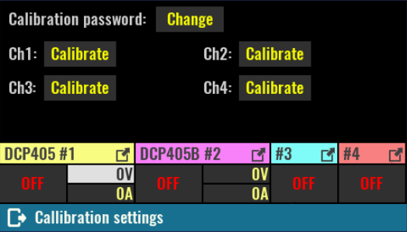
SCPI
CALibration:PASSword:NEW {<old>}, {<new>}

Using this page it is possible to access the calibration parameters of all installed channels as well as to start the calibration on any of the channels.

